Super Sentences Writing Model in KS1
In Year 1, children are introduced to a basic writing sequence founded on the concept of dictation; using a structured approach children are enabled to build strong foundational writing skills and knowledge, as well as fluency. Children are taught to revise, edit and proofread using a shared writing model, prioritising quality over volume to master spelling, handwriting and sentence construction. Throughout the writing sequence, support and scaffolding is given where necessary, with opportunities to deepen learning when appropriate.
Five-day planning sequence
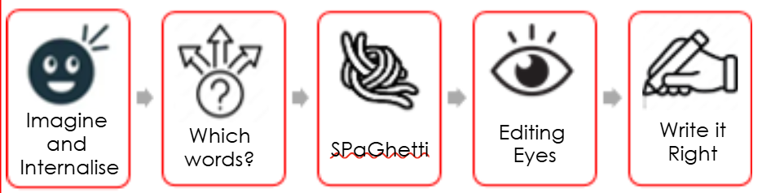
Day 1: Imagine and internalise
After sharing a high-quality text from the writing spine (linked to a termly theme), children are shown an image from the text; children are given the opportunity to talk about the image and practise their oracy skills. A sentence (does not have to be taken from the text, but be linked) is introduced to the children, which is read aloud with modelled prosody; children repeat orally. If appropriate, the sentence type (statement, command, exclamation or question) is made explicit.
Day 2: Which words?
This lesson explores words in the sentence. Manipulatives and visual prompts are used to represent the number of words there are, while allowing for visualisation of appropriate spacing between words. Children have the opportunity to practise oracy and phonics skills as they explore the words with the support of sound buttons. Tricky words are orally practised using mnemonics and dual-coding as visual prompts. If appropriate, children’s learning is further challenged through an additional sentence.
Day 3: Successful SPaG
With a focus on letter formation, spelling, punctuation and grammar children will have the opportunity to practise gross and fine motor skills to support letter formation; the difference between capital letters and lower case are highlighted during this lesson. Spellings are revisited from the previous day, and if appropriate, children have the opportunity to extend their learning with the challenge sentence introduced the previous day.
Day 4: Editing eyes
Children are introduced to the original sentence with spelling, punctuation or grammatical errors. Through the use of talk partners and class discussion, children identify the mistakes together. Teacher modelling demonstrates how to edit the sentence(s) to correct the errors, before independently editing in their own books.
Day 5: Write it right
As the teacher dictates the sentence which has been explored throughout the week, children transcribe into their books independently. Using a given checklist (handwriting, spelling, punctuation and grammar) children self-check and edit their work independently. To extend learning further, children will be given the opportunity to add their own sentences (innovation), before checking and editing.

In Year 2, children continue to use the Super Sentences writing model to ensure consolidation of strong foundational writing skills. As children’s understanding and learning develops, the writing model adapts and begins to incorporate elements of the Hampshire writing model, where compositional skills are introduced and developed ready to transition into KS2.

